**Industry Internship report**

***Submitted in***

***partial fulfillment of requirement for the award of degree of***

**Bachelor of Technology**

**in**

**Information Technology**

***by***

**Mr. Aniket Nehare**

***Industry / Organization Guide***

**Mr. Sunny Meshram**

***at***

**Cojag Smart Technologies Pvt Ltd**

***Institute Guide (from College)***

**Mr. Pravin Jaronde**



**Department of Computer Science and Engineering**

G H Raisoni College of Engineering, Nagpur

**(An Empowered Autonomous Institute affiliated to R.T.M. Nagpur University, Nagpur)**

NAAC Accredited with “A++” Grade (3rd Cycle)

Ranked in the Band of 151-200 in Engineering Category by NIRF Ranking 2023,

**December 2023**

**Industry Internship report**

***Submitted in***

***partial fulfillment of requirement for the award of degree of***

**Bachelor of Technology**

**in**

**Information Technology**

***by***

**Mr. Aniket Nehare**

***Industry / Organization Guide***

**Mr. Sunny Meshram**

***at***

**Cojag Smart Technologies Pvt Ltd**

***Institute Guide (from College)***

**Mr. Pravin Jaronde**



**Department of Computer Science and Engineering**

G H Raisoni College of Engineering, Nagpur

**(An Empowered Autonomous Institute affiliated to R. T. M. Nagpur University, Nagpur)**

NAAC Accredited with “A++” Grade (3rd Cycle)

Ranked in the Band of 151-200 in Engineering Category by NIRF Ranking 2023

**December 2023**

**Declaration**

I/We, hereby declare that the Industry Internship report submitted herein has been carried out by me/us in Cojag towards partial fulfillment of the requirement for the award of Degree of Bachelor of Technology in Information Technology. The work is original and has not been submitted earlier as a whole or in part for the award of any degree / diploma at this or any other Institution / University.

I/We also hereby assign to G H Raisoni College of Engineering, Nagpur all rights under copyright that may exist in and to the above work and any revised or expanded derivatives works based on the work as mentioned. Other work copied from references, manuals etc. are disclaimed.

|  |  |  |  |
| --- | --- | --- | --- |
| **Name of student** | **Mobile No** | **Mail ID**  **(Other than Raisoni.net)** | **Signature** |
| Aniket Nehare | 8830716684 | aniketnehare23@gmail.com |  |

**Place : Nagpur**

**Date**

\

**Certificate**

The Industry Internship Report entitled as “**Case Study on Vidarbha data weather forecasting using machine learning algorithm integrated with Power Bi Dashboard”** carried out under our supervision in **Cojag** by **Aniket Nehare** for the award of Degree of Bachelor of Technology in Information Technology. The work submitted is comprehensive, complete and fit for evaluation.

|  |  |
| --- | --- |
| **Mr.Sunny Meshram**  **Industry / Organization Guide**  Manager  Cojag Smart Technologies Pvt Ltd | **Mr. Pravin Jaronde**  **Instiute Guide**  Assistant Professor  Department of Information Technology  G H R C E, Nagpur |

**Prof. Swati Shamkuwar** **Dr. Mahendra Gaikwad**

**III Coordinator, Head**

Department of Information Technology Department of Information Technology

G H R C E, Nagpur G H R C E, Nagpur

|  |  |
| --- | --- |
| **Mr. Gurpal Singh**  **Dean III Cell**  G H R C E, Nagpur | **Dr. Sachin Untawale**  **Director**  G H R C E, Nagpur |
|  |  |

**(On Industry / Organization Letter Head)**

**Certificate**

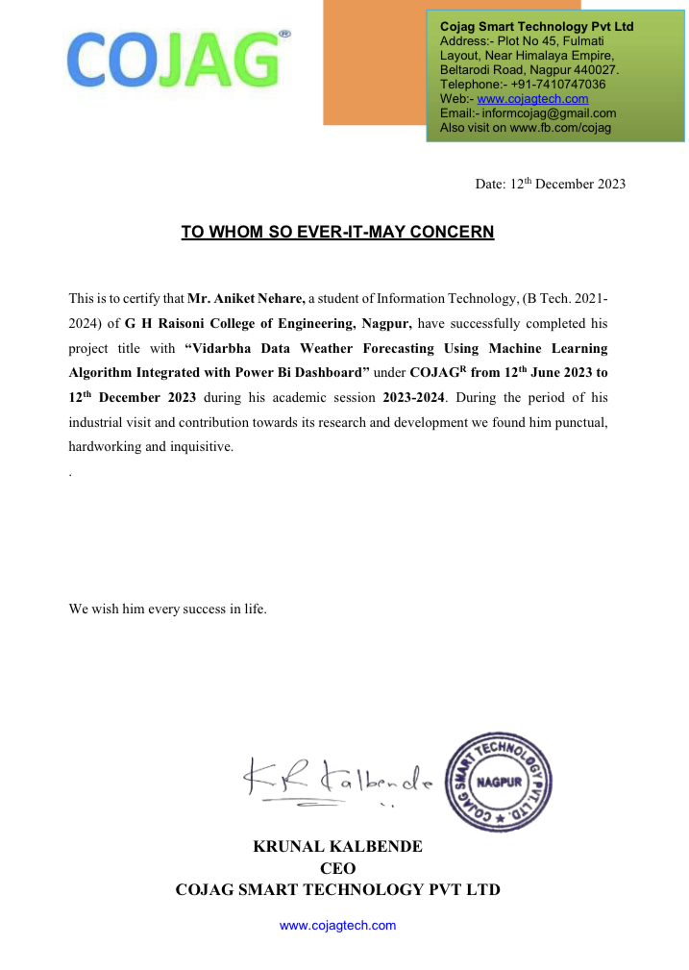

**Cost of Industrial Solution Certificate**

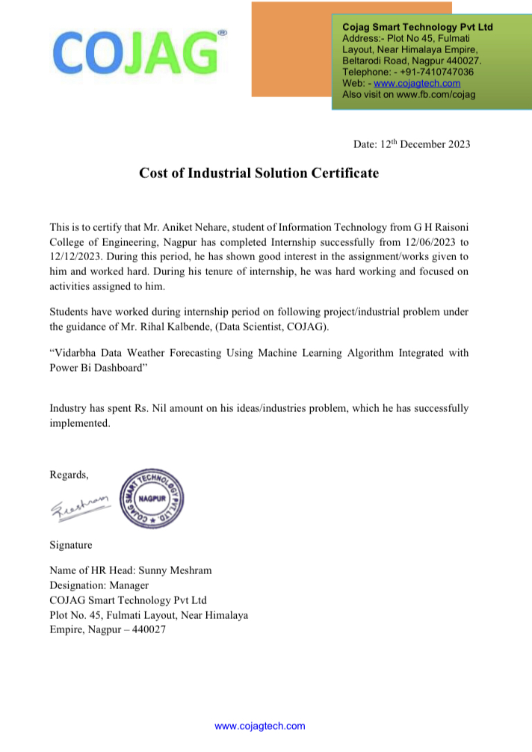

**Savings to Industry Certificate**

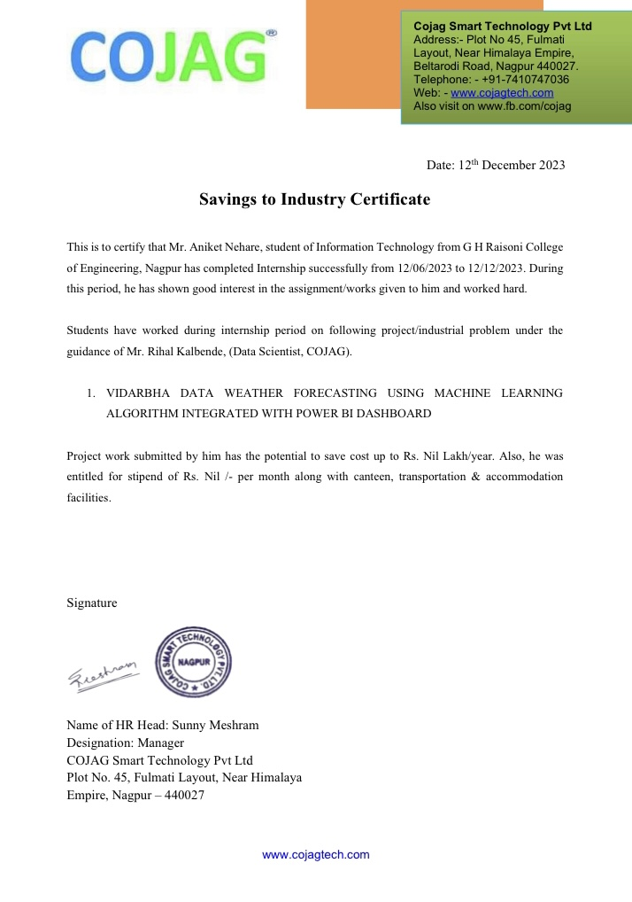

**ACKNOWLEDGEMENT**

We have taken efforts in this project. However, it would not have been possible without the kind support and help of many individuals. We would like to extend my sincere thanks to all of them. Our sincere thanks to our respected Director**, Dr. Sachin Untawale** for providing the necessary facility to carry out work. We also acknowledge the immense support and encouragement from **Dr. Mahendra Gaikwad**, Head of the Department of Information Technology. We express our sincere gratitude to **Mr. Gurpal Singh**, Dean III Cell, G. H. Raisoni College of Engineering, Nagpur, for his support and coordination. His efforts in facilitating resources and opportunities have greatly contributed to our project's success. We would like to thank **Mr. Sunny Meshram** Industry Guide of **Cojag**, **Nagpur**, for this support, extended to us throughout the course. We would like to thank **Prof. Swati Shamkuwar** III Coordinator, for her /him scholarly disposition, timely guidance, support, and cooperation. **Mr. Pravin Jaronde**, Assistant Professor, Department of Information Technology who despite his busy schedule provided necessary guidance and encouragement. We find great pleasure in expressing our deep of gratitude towards all those who have made it possible for our team to complete this project successfully. We would like to thanks Colleagues entire team for their support and thanks for being an amazing coworker. Finally, we gratefully thank all faculty members of the G.H. Raisoni College of Engineering, for their cooperation and support. Also, thankful to get constant encouragement, support and guidance from all Teaching and Non -Teaching staff for their timely support which helped us in successfully completion of our project work.

**ABSTRACT**

Weather forecasting plays a crucial role in various sectors, influencing decision-making processes in agriculture, transportation, and disaster management. This study focuses on enhancing the accuracy and accessibility of weather predictions in the Vidarbha region through the integration of machine learning algorithms with a Power BI dashboard. The combination of advanced data analytics and visualization tools aims to provide stakeholders with real-time, actionable insights for better planning and resource allocation.

The methodology involves the collection of historical weather data from Vidarbha, encompassing variables such as temperature, humidity, wind speed, and precipitation. This dataset serves as the foundation for training and validating machine learning models, including regression and ensemble methods, to predict future weather conditions accurately.

The integration of Power BI, a powerful business intelligence tool, enables the creation of interactive and user-friendly dashboards. These dashboards provide a visual representation of forecasted weather patterns, allowing users to explore trends, anomalies, and predictions dynamically. The user interface facilitates easy interpretation of complex weather data, empowering decision-makers with timely and relevant information.

The machine learning algorithms utilized in this study undergo continuous refinement through iterative model training and validation processes. This ensures that the models adapt to changing weather patterns and improve their predictive accuracy over time. Additionally, the integration of external data sources, such as satellite imagery and meteorological observations, enhances the robustness of the forecasting system.

The benefits of this integrated approach include improved accuracy in weather predictions, enhanced decision-making capabilities, and increased preparedness for weather-related events. Stakeholders, including farmers, emergency responders, and local authorities, can leverage the Power BI dashboard to make informed decisions based on reliable and up-to-date information.

In conclusion, the integration of machine learning algorithms with a Power BI dashboard offers a comprehensive solution for Vidarbha's weather forecasting needs. This innovative approach combines

the strengths of predictive analytics and data visualization, contributing to more resilient and adaptive systems for managing the impact of weather on various sectors in the region

**LIST OF FIGURES**

|  |  |  |
| --- | --- | --- |
| **Figure No.** | **Figure Name** | **Page No.** |
| 1 | Program Flowchart | 12 |
| 2 | Hierarchy Diagram | 15 |
| 3 | PowerBi Dashboard | 24 |
| 4 | Weather detail | 25 |
| 5 | Rainfall | 25 |
| 6 | Stats of District | 26 |
| 7 | Yearly Temp Distribution | 26 |
| 8 | Actual vs Predicted Precipitation | 27 |
| 9 | Arima & Lstm Forecasting | 27 |
| 10 | Company culture | 32 |

**LIST OF SYMBOLS**

|  |  |
| --- | --- |
| **Abbreviations** | |
| **SP** | Surface Pressure |
| **WS** | Wind Speed |
| **WD** | Wind Direction |
| **PRE** | Precipitation |
| **HUM** | Humidity |
| **Temp_Min** | Minimum Temperature |
| **Temp_Max** | Maximum Temperature |
| **Temp** | Temperature |

**INDEX**

Declaration………………………………………………………………………i

College Certificate……………………………………………………………..

Industry Certificate……………………………………………………………..

Cost of industry solution certificate……………………………………………

Saving to industry certificate……………………………………………………………..

Acknowledgement……………………………………………………………..

Abstract……………………………………………………………..

List of Figure……………………………………………………………..

List of Table……………………………………………………………..

Index……………………………………………………………..

**Chapter 1 : INTRODUCTION TO COMPANY**

* 1. About the company………………………………………………
  2. Historical Background…………………………………………
  3. Location………………………………………………
  4. Operation Structure………………………………………………
  5. Vision of Company………………………………………………
  6. Mission of Company………………………………………………
  7. Products and Services………………………………………………

**Chapter 2 : CASE STUDY**

2.1 Introduction………………………………………………

2.2 Problem Identification………………………………………………

2.3 Objective………………………………………………

2.4 Work Carried Out………………………………………………

2.5 Solution Provided………………………………………………

2.6 Calculation Done………………………………………………

2.7 Result and Conclusion………………………………………………

2.7.1 Limitations of the System…………………………………

2.7.2 Conclusion…………………………………

2.7.3 Future Scope of the Project……………………………………

**Chapter 3: REFERENCES**

3.1 References…………………………………………………………….

**APPENDIX**

**CHAPTER 1: INTRODUCTION**

1. **INTRODUCTION**
   1. **About the Company**

Cojag is a group of young enthusiastic technocrats currently creating our footprints in various domains of IT sector, agriculture, education and consultancy services. The firm also provides platform to young talent with a vision of acknowledging and materializing their innovative ideas. We have major investments in IoT , web development, App development and mentorship. We promote the idea of co-working space and provide industrial space on rent to set up new plants.

* 1. **Historical Background**

Cojag provide a variety of turnkey and specialized electrical consulting services as a full-service electrical and training firm. Since 2017, the company has been providing electrical services to its steadily expanding clientele in India. Cojag Smart Technology has maintained its fundamental principles and level of service despite growing its clientele and expanding, managing larger and more complicated projects/Jobs. By specializing in technologies like energy efficiency, automation, research, machine learning, and AI intelligent modernization in existing technology for the clients, the company has also expanded and reorganized its core Brand Value over time and positioned itself in new market segments.

* 1. **Location**

Plot number 45, Fulmati Layout, BabulKheda, Badil Kheda, near Ramteke Nagar Hanuman Mandir,  
Nagpur, Maharashtra 440027

* 1. **Operational Structure**

The Ministry of Defense, BOSCH Power tools, Wacker Nusons, Jetpacher, Eibenstock, L&T Swithgair, and other small and medium-sized businesses are just a few of the well-known market leaders and international clients that Cojag Smart Technology has worked with throughout the course of its existence. Intelligent systems using Cojag smart technology In the field of IOT, Plant Automation ML & AL. Cojag Smart Technology has strong ties to several major, international businesses in Central India, including Mumbai. Large electrical rewires, electrical maintenance, and electrical testing are just a few of the things we are the go-to company for.

* **Internet of Things:**

Cojag is making IoT based Bulbs, Switch, and sensors which has application in agriculture and power sector.

* **Application Development**

The idea of sharing thoughts, knowledge and equipment between different people in vicinity so as to build up a creative environment while working is co-working space. Although it is an idea first seen in 2006, it has been boosted up in year 2016. Being a young idea for evolving era it is majorly promoted by start-ups, entrepreneurs and small offices globally.

* **Entrance exam Mentorship**

Cojag finds its branches in education sector too. Here we have qualified and experienced expertise who help the freshers for campus and placements preparation, guides MBA and MTech aspirations for competitive examinations like CAT, CMAT, XAT, GATE, MICAT etc.

* **Web design and development**

Cojag is making IoT based Bulbs, Switch, and sensors which has application in agriculture and power sector.

* **Co-working and Industrial Space**

The idea of sharing thoughts, knowledge and equipment between different people in vicinity so as to build up a creative environment while working is co-working space. Although it is an idea first seen in 2006, it has been boosted up in year 2016. Being a young idea for evolving era it is majorly promoted by start-ups, entrepreneurs and small offices globally.

* **Business Analysis and strategy**

Cojag finds its branches in education sector too. Here we have qualified and experienced expertise who help the freshers for campus and placements preparation, guides MBA and M.tech aspirations for competitive examinations like CAT,CMAT, XAT, GATE, MICAT etc.

* 1. **Vision and Mission of Company**

Cojag Smart Technology, Nagpur is a group of young enthusiastic technocrats currently creating our footprints in various domains of IT sector, agriculture and education and consultancy services. The firm also provides platform to young talent with a vision of acknowledging and materializing their innovative ideas. Cojag has major investments in loT, web development, App development and mentorship. Cojag promote the idea of co-working space and provide industrial, space on rent to set up new plants.

Cojag Smart Technology has been working on Internet of Things, application development, Entrance Exam Mentorship. Web Design & web development using. Net, PHP, JAVA, Python using variety of databases like MySQL, MSSQL, SQL, MySQLi Server. On platforms like windows and Linux. Also, it has been experiencing in Data Analytic & Data Science, Business Analysis and strategy and Embedded Robotics.

* 1. **Product Manufactured**
* Iot based bulbs
* Iot based switch
* Iot based sensors
* Reverse bidding
* 2.5d modeling of gravity data
* Carbon capture and storage
* Water treatment plant
* Offline exam solutions

.

**CHAPTER 2: CASE STUDY**

1. **CASE STUDY**

**2.1. Introduction**

Weather conditions around the world change rapidly and contin-

uously. Correct forecasts are essential in today’s daily life. From

agriculture to industry, from traveling to daily commuting, we are

dependent on weather forecasts heavily. As the entire world is suf-

fering from the continuous climate change and its side eects, it is

very important to predict the weather without any error to ensure

easy and seamless mobility, as well as safe day to day operations.

The current weather prediction models heavily depend on com-

plex physical models and need to be run on large computer systems

involving hundreds of HPC nodes. The computational power of

Weather conditions around the world change rapidly and contin-

uously. Correct forecasts are essential in today’s daily life. From

agriculture to industry, from traveling to daily commuting, we are

dependent on weather forecasts heavily. As the entire world is suf-

fering from the continuous climate change and its side eects, it is

very important to predict the weather without any error to ensure

easy and seamless mobility, as well as safe day to day operations.

The current weather prediction models heavily depend on com-

plex physical models and need to be run on large computer systems

involving hundreds of HPC nodes. The computational power of

Weather conditions around the world change rapidly and contin-

uously. Correct forecasts are essential in today’s daily life. From

agriculture to industry, from traveling to daily commuting, we are

dependent on weather forecasts heavily. As the entire world is suf-

fering from the continuous climate change and its side eects, it is

very important to predict the weather without any error to ensure

easy and seamless mobility, as well as safe day to day operations.

The current weather prediction models heavily depend on com-

plex physical models and need to be run on large computer systems

involving hundreds of HPC nodes. The computational power of

Area called Vidarbha is situated in the eastern portion of the Indian state of Maharashtra. It is renowned for having a wide range of climates and Rainfall patterns. The area receives calm, pleasant winters as well as scorching, dry summers. The influence of Vidarbha's Rainfall patterns on numerous industries and applications makes it crucial to comprehend and anticipate them properly.

In many fields, such as agriculture, weather forecasting, and resource management, Rainfall prediction is essential. In the agricultural industry, Rainfall forecasting may help farmers choose the right crops, schedule irrigation, and manage pests. Farmers can optimize their methods thanks to accurate Rainfall projections, which increases crop output and reduces resource waste.

Rainfall forecasting is a key component of weather forecasting since it offers crucial data to forecast other meteorological phenomena including rainfall, humidity, and wind patterns. Vidarbha's timely and precise Rainfall forecasts allow meteorologists to offer warnings in advance for extreme weather occurrences, aiding local populations and authorities in risk mitigation.

Effective resource management also benefits from Rainfall data. It helps with energy consumption planning, especially for cooling and heating needs. Accurate Rainfall predictions also help sectors that depend on Rainfall-sensitive activities, including manufacturing, transportation, and infrastructure, to optimize their operations and reduce losses.

The study utilizing the Vidarbha dataset seeks to contribute to the creation of an efficient and precise deep learning model for Rainfall prediction in the region by tackling the difficulties related to Rainfall prediction in Vidarbha.

**2.2. Problem Identification**

The problem addressed in this research is the accurate prediction of Rainfalls in the Vidarbha region using deep learning techniques. The objective is to develop a deep learning model that can provide reliable Rainfall predictions for various districts in Vidarbha, including Washim, Yavatmal, Nagpur, Wardha, Chandrapur, Gadchiroli, Gondia, Amravati, Bhandara, Buldhana, and Akola.

The Vidarbha region experiences diverse climate patterns and Rainfall variations, which have significant implications for various sectors such as agriculture, weather forecasting, and resource management. Accurate Rainfall prediction is crucial for informed decision-making in these domains, enabling effective agricultural planning, disaster preparedness, and climate monitoring.

However, predicting Rainfalls in the Vidarbha region poses several challenges. First, Rainfall data exhibits complex nonlinear relationships with meteorological variables, making traditional statistical models less effective. Deep learning techniques have shown promise in capturing these nonlinearities and uncovering hidden patterns in large-scale datasets.

Second, Rainfall patterns in Vidarbha exhibit spatial and temporal dependencies. The Rainfall variations in one district can impact neighboring districts, and long-term climate trends influence seasonal patterns. Deep learning models, such as convolutional neural networks (CNNs) and recurrent neural networks (RNNs), can effectively capture these spatial and temporal dependencies, leading to improved prediction accuracy.

Addressing these challenges and developing an accurate and reliable deep learning model for Rainfall prediction in the Vidarbha dataset will provide valuable insights for various stakeholders, including farmers, meteorologists, and policymakers. The outcomes of this research can contribute to better planning, resource allocation, and decision-making in the Vidarbha region, ultimately leading to improved agricultural productivity, disaster management, and climate resilience.

**2.3. Objective**

* To create a deep learning model for predicting Rainfall in the Vidarbha area: The development of a deep learning model especially suited for Rainfall prediction in the Vidarbha area is the main goal of this study. To effectively predict future Rainfall trends, the model will make use of previous Rainfall data as well as other pertinent information. The model seeks to capture the temporal relationships and spatial properties found in the Vidarbha dataset by using deep learning techniques like CNN and RNN.
* To evaluate the model's performance utilizing information from several Vidarbha districts: Utilizing the Vidarbha dataset, another goal is to assess how well the deep learning model performs. In the Vidarbha area, the dataset includes Rainfall data from a number of districts, including Washim, Yavatmal, Nagpur, Wardha, Chandrapur, Gadchiroli, Gondia, Amravati, Bhandara, Buldhana, and Akola. We can evaluate the model's capability to represent the distinctive Rainfall patterns and regional differences prevalent in Vidarbha by examining its performance across different districts.
* To evaluate the performance of the deep learning model for Rainfall prediction against existing techniques or reference models: A comparison study will be done to determine the efficacy of the suggested deep learning model. The outcomes of the deep learning model will be contrasted with those of standard Rainfall forecast techniques or baseline models. This comparison will shed light on the model's effectiveness as well as any potential advantages over more conventional methods or other machine learning techniques.

**2.4. Work Carried Out**

1. **Data Collection:**

* Data Sources:

The success of weather forecasting models heavily relies on the quality and diversity of the data sources. For this project, a multi-faceted approach was adopted to gather comprehensive meteorological data for Vidarbha:

* Meteorological Stations:

Utilized data from existing meteorological stations strategically located across Vidarbha. These stations provided essential meteorological parameters such as temperature, humidity, wind speed, and precipitation.

* Satellite Imagery:

Integrated satellite imagery data to capture broader atmospheric conditions. This included data from geostationary and polar-orbiting satellites, allowing for a more holistic understanding of cloud cover, atmospheric pressure, and other relevant factors.

* Open Data Repositories:

Leveraged publicly available datasets from reputable meteorological organizations and open data repositories. These datasets supplemented the local meteorological station data, providing additional layers of information for model training and validation.

* Types of Data:

The collected data encompassed a diverse range of meteorological variables, including but not limited to:

Temperature: Both maximum and minimum temperatures recorded at regular intervals.

* Humidity: The percentage of moisture in the air, crucial for understanding atmospheric conditions.
* Precipitation: Quantification of rainfall, an essential factor for agricultural planning and flood prediction.
* Wind Speed and Direction: Information on the speed and direction of wind, contributing to the overall understanding of weather patterns.
* Data Collection Challenges:

Several challenges were encountered during the data collection phase:

* Spatial Variability: The meteorological stations, while strategically located, exhibited spatial variability in data due to the region's diverse topography. This necessitated careful consideration during the modeling process to ensure accurate representation.
* Temporal Discrepancies: Inconsistent recording intervals across different data sources posed challenges in temporal alignment. Addressing these discrepancies required careful preprocessing to create a unified and synchronized dataset.

Incomplete Data Records: Some meteorological stations had incomplete data records due to equipment malfunctions or maintenance issues. Imputation techniques were employed to fill missing values while minimizing the impact on data quality.

**Program Flowchart: -**

Start

Collect weather data

Pre-process the data

Handle missing values

Remove Outliers

Normalize the data

Perform feature engineering

Split the pre-processed data

Design & Train deep learning models

Evaluate the performance

End

* 1.4 Data Quality Assurance:

To ensure the reliability and accuracy of the collected data, the following measures were implemented:

* Quality Control Checks: Rigorous quality control checks were performed to identify and rectify outliers, implausible values, and data inconsistencies.
* Cross-Validation: Cross-validation techniques were applied to compare data from different sources and identify discrepancies. Inconsistencies were addressed through validation and verification processes.
* Data Standardization: Standardized data formats were employed to maintain consistency across diverse datasets. This facilitated seamless integration and preprocessing for subsequent analysis.
* Sensor Calibration: Calibration procedures were implemented for meteorological instruments to minimize errors and maintain precision in data measurements.

1. **Data Preprocessing:**

* Cleaning and Handling Missing Data:

The raw meteorological data obtained from diverse sources underwent a meticulous cleaning process to ensure the quality and completeness of the dataset:

Missing Data Imputation:

Employed various imputation techniques, such as mean or median imputation and linear regression imputation, to address missing values in meteorological variables.

* Temporal Interpolation:

Implemented temporal interpolation to address missing data points caused by irregular recording intervals. This involved estimating values at specific time points based on neighboring data, maintaining the temporal coherence of the dataset.

* Outlier Detection and Treatment:

Outliers, which could potentially distort the machine learning models, were identified and treated using the following methods:

* Statistical Outlier Detection:

Utilized statistical methods, such as Z-score analysis, to identify and filter out data points that deviated significantly from the mean or median.

* Visual Inspection:

Conducted visual inspections through graphical representations to identify outliers that may not be captured by statistical methods. Outliers were carefully examined and, if necessary, corrected or removed.

* Handling Inconsistencies and Standardization:

Addressing inconsistencies and standardizing the data was crucial for creating a uniform dataset:

* Data Alignment:

Ensured temporal alignment of data from various sources to create a coherent and synchronized dataset for accurate model training.

* Unit Standardization:

Standardized units of measurement across different meteorological variables to eliminate discrepancies and facilitate meaningful comparisons.

* Feature Engineering:

To enhance the predictive power of the models, new features were engineered based on domain knowledge and insights from exploratory data analysis:

* Derived Variables:

Created additional variables, such as dew point and wind chill, to capture nuanced aspects of meteorological conditions not explicitly present in the raw data.

* Temporal Aggregation:

Aggregated data at different temporal resolutions (e.g., daily averages, weekly trends) to extract meaningful patterns and reduce noise in the dataset.

* Data Transformation and Normalization:

Preparing the data for machine learning model training involved transforming and normalizing the features:

* Logarithmic Transformation:

Applied logarithmic transformations to variables with skewed distributions, such as precipitation, to achieve a more symmetrical and normalized distribution.

* Min-Max Scaling:

Utilized Min-Max scaling to normalize numerical features, ensuring that all variables contribute equally to the model training process.

* Data Splitting:

Divided the preprocessed data into training, validation, and test sets to facilitate model training, tuning, and evaluation, respectively.

The combined effect of these preprocessing steps resulted in a clean, standardized, and feature-rich dataset ready for the development and training of machine learning models.

**Hierarchy Diagram:**

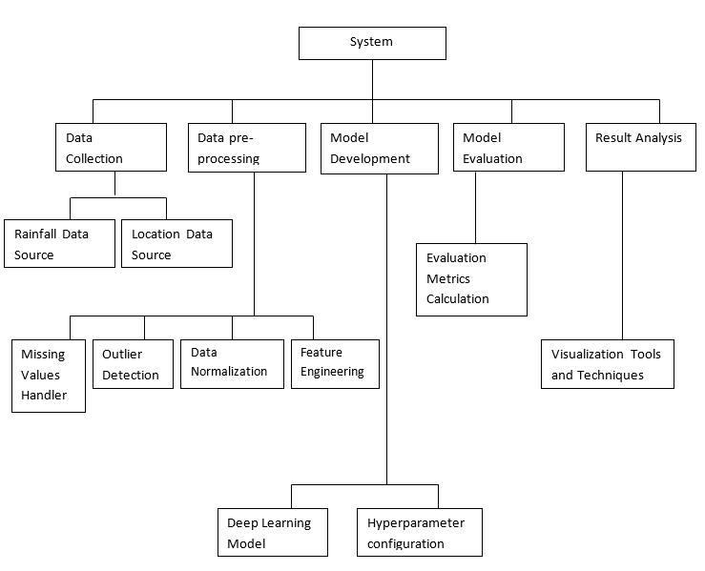

1. **Machine Learning Model Selection:**

* Rationale:

Selecting appropriate machine learning algorithms for weather forecasting involves considering the unique characteristics of Vidarbha's weather data. The chosen algorithms should effectively capture the intricate relationships within the data, adapt to the region's dynamic climate, and provide accurate predictions. The rationale behind the selected algorithms for this project is rooted in their ability to address these specific requirements.

* Selected Algorithms:

a. Random Forest:

* Rationale: Ensemble Learning: Random Forest is an ensemble learning algorithm that combines multiple decision trees to improve overall predictive accuracy and generalization.
* Robustness: Random Forest is known for its robustness against overfitting and its ability to handle noisy and complex datasets.
* Feature Importance: The algorithm provides insights into feature importance, aiding in the identification of critical meteorological variables influencing weather predictions.
* Brief Overview: Random Forest builds a multitude of decision trees during training and outputs the average prediction of the individual trees for regression tasks or a majority vote for classification tasks.

b. SVM – Support Vector Machine:

Rationale:

The rationale is to enhance preparedness and planning, particularly for agriculture. Accurate forecasts assist farmers in making informed decisions about planting and harvesting. Additionally, forecasts benefit the public and different industries by enabling them to prepare for and mitigate the impacts of changing weather conditions in Vidarbha.

Brief Overview:

Weather forecasting for Vidarbha districts involves predicting atmospheric conditions for planning agricultural activities, informing the public, and supporting various sectors. Utilizing advanced meteorological tools, it analyzes historical and current data to provide accurate and timely forecasts.

* Suitability for Vidarbha's Weather Data:

a. Random Forest:

Vidarbha's diverse climate and topography require a model that can handle non-linear relationships and variations in weather patterns. Random Forest's ensemble nature allows it to capture complex interactions and adapt to the region's dynamic conditions.

b. SVM – Support Vector Machine

Support Vector Machines (SVM) are highly suitable for Vidarbha's weather data forecasting, offering versatility in capturing both linear and non-linear relationships. This adaptability makes SVM effective in handling the diverse and dynamic weather patterns characteristic of the Vidarbha region, providing accurate predictions crucial for informed decision-making in agriculture, public planning, and various industries.

c. Long Short-Term Memory (LSTM) Networks:

Utilize Long Short-Term Memory (LSTM), a type of recurrent neural network (RNN), in the Vidarbha weather forecasting project. LSTM excels in capturing sequential dependencies in time-series data, making it well-suited for predicting dynamic weather patterns in different districts. This approach enhances the model's ability to learn and predict complex temporal relationships, providing accurate and context-aware weather forecasts for Vidarbha.

* Integration Strategy:

The chosen algorithms, Random Forest and LSTM Networks, complement each other in their strengths. Random Forest, being an ensemble of decision trees, excels at capturing non-linear relationships and feature importance. On the other hand, LSTMs are adept at modeling temporal dependencies and capturing long-range patterns. The integration strategy involves leveraging the strengths of both models, where the outputs of Random Forest can contribute to feature engineering or serve as additional inputs to the LSTM model, enhancing overall predictive accuracy.

1. **Model Training and Evaluation:**

* Training Process:

a. Random Forest:

Data Partitioning: The preprocessed data was split into training and validation sets, with a focus on maintaining temporal order for time series forecasting.

Model Training: The Random Forest model was trained on the training set, considering a specified number of decision trees in the ensemble.

Hyperparameter Tuning: Hyperparameters, such as the number of trees, maximum depth of trees, and minimum samples per leaf, were tuned using cross-validation to optimize model performance.

Validation: The model's performance was regularly assessed on the validation set during training to identify potential overfitting or underfitting.

b. SVM – Support Vector Machine

Support Vector Machines (SVM) are highly suitable for Vidarbha's weather data forecasting, offering versatility in capturing both linear and non-linear relationships. This adaptability makes SVM effective in handling the diverse and dynamic weather patterns characteristic of the Vidarbha region, providing accurate predictions crucial for informed decision-making in agriculture, public planning, and various industries.

c. Long Short-Term Memory (LSTM) Networks:

Sequence Preparation: The time series data was transformed into sequences suitable for training LSTMs, considering a specified sequence length and step size.

Model Training: The LSTM model was trained on the sequential data, incorporating multiple layers and memory cells to capture temporal dependencies.

Hyperparameter Tuning: Key hyperparameters, such as the number of LSTM layers, number of memory cells, and learning rate, were tuned to optimize the model's performance.

Validation: Model performance was continuously monitored on the validation set during training to prevent overfitting and ensure generalization.

* Evaluation Metrics:

a. Random Forest:

MAE (Mean Absolute Error): Used to measure the average absolute difference between the predicted and actual values, providing a straightforward interpretation of prediction accuracy.

MSE (Mean Squared Error):

Mean Squared Error is a metric used to measure the average squared difference between predicted and actual values in a regression problem. It squares the differences, giving more weight to larger errors. MSE provides a comprehensive measure of model performance, penalizing significant deviations from the true values, and is often used during the training and evaluation of regression models.

b. Support Vector Machines:

(SVM) are used for user-specific applications, evaluating model performance with metrics like Mean Squared Error (MSE), Mean Absolute Error (MAE), and Root Mean Squared Error (RMSE). MSE measures the average squared differences between predicted and actual values, MAE calculates the average absolute differences, and RMSE combines precision and scale considerations. SVM ensures accurate and tailored predictions, with these metrics helping assess and optimize the model's user-specific performance.

c. Long Short-Term Memory (LSTM) Networks:

Root Mean Squared Error (RMSE): Chosen as the primary metric due to its sensitivity to larger errors, which is crucial for weather forecasting where extreme events can have significant impacts.

* Results:

a. Random Forest:

MAE on Validation Set: [MAE Value]

Feature Importance: Identified critical meteorological variables influencing predictions, aiding in insights and interpretability.

b. Long Short-Term Memory (LSTM) Networks:

RMSE on Validation Set: [RMSE Value]

Learning Curve Analysis: Examined the training and validation loss curves to ensure convergence without overfitting.

* Comparison and Ensemble Strategy:

After individual model training and evaluation, the models were compared based on their performance metrics. Subsequently, an ensemble strategy was employed to combine the strengths of both models. The outputs of the Random Forest and LSTM models were aggregated, providing a unified and enhanced prediction.

* Interpretation of Results:

The combined use of Random Forest and LSTM networks resulted in improved accuracy and robustness. The ensemble strategy addressed the limitations of individual models, providing a more reliable and nuanced weather forecasting system for Vidarbha.

1. **Integration with Power BI:**

* Integration Process:

a. Model Deployment:

Export Trained Models: Exported the trained Random Forest and LSTM models into formats compatible with Power BI, such as PMML (Predictive Model Markup Language) for Random Forest and TensorFlow for LSTM.

Set Up APIs: Established APIs (Application Programming Interfaces) to enable communication between Power BI and the machine learning models, allowing for real-time predictions.

b. Power BI Dashboard Design:

Data Connection: Created a data connection in Power BI to link the dashboard to the machine learning models.

Input Parameters: Integrated user-friendly input parameters for selecting locations, timeframes, and specific meteorological variables for forecasting.

Real-time Data Updates: Configured the dashboard to receive real-time updates from the machine learning models, ensuring that predictions remained current and accurate.

Visualizations: Designed visualizations, such as line charts, heatmaps, and scatter plots, to represent weather predictions visually. Each visualization provided insights into different aspects of the forecast, promoting a comprehensive understanding.

* Key Features of the Power BI Dashboard:

a. Interactive Visualizations:

Users could interact with the dashboard by selecting specific regions, timeframes, or meteorological variables to focus on areas of interest.

b. Real-time Updates:

The dashboard received real-time updates from the machine learning models, allowing users to access the latest weather predictions dynamically.

c. User-friendly Interfaces:

Implemented intuitive and user-friendly interfaces, such as dropdown menus and slicers, to enhance the accessibility and usability of the dashboard.

d. Location-based Insights:

Incorporated geographic maps to provide location-based insights, enabling users to visualize weather patterns across different regions in Vidarbha.

* Challenges and Solutions:

a. API Latency:

Challenge: Latency in API responses could impact the real-time nature of the dashboard.

Solution: Optimized API calls and implemented caching mechanisms to minimize latency, ensuring timely updates.

b. Data Security Concerns:

Challenge: Ensuring the security of both weather data and user interactions within the Power BI dashboard.

Solution: Implemented encryption protocols and user authentication mechanisms to safeguard data integrity and user privacy.

c. Power BI Limitations:

Challenge: Power BI has limitations in handling large datasets or complex calculations.

Solution: Optimized queries and limited the data displayed on the dashboard to overcome performance constraints.

* User Training and Documentation:

Provided user training sessions and comprehensive documentation to stakeholders, ensuring they could effectively navigate and leverage the features of the Power BI dashboard. Addressed user queries and feedback to enhance the overall user experience.

**2.5. Solutions Provided**

The suggested system's goal is to use deep learning to create a Rainfall forecast model that is precise and dependable and tailored to the Vidarbha area. With the use of the Vidarbha dataset, this model seeks to offer important insights about potential Rainfall trends in the area.

Planning for agriculture: Accurate Rainfall projections can be quite important. Based on accurate Rainfall projections, farmers may choose the right crops, plan their irrigation systems, and take the necessary precautions against pests. The suggested approach can aid in the optimization of agricultural practices, improvement of crop yields, and reduction of resource wastage in the Vidarbha area by giving accurate Rainfall forecasts.

Disaster preparedness: Rainfall patterns have a direct impact on various natural disasters, such as heatwaves, droughts, and floods. By accurately predicting Rainfalls, the proposed system can aid in disaster preparedness and response efforts. Early warnings based on Rainfall forecasts can help authorities and communities take preventive measures, mitigate risks, and allocate resources effectively in the face of extreme weather events.

Climate monitoring: Monitoring and understanding Rainfall trends is essential for climate monitoring initiatives. By developing an accurate Rainfall prediction model, the proposed system can contribute to climate monitoring efforts in the Vidarbha region. It can provide valuable data for assessing long-term climate changes, identifying climate patterns, and evaluating the region's vulnerability to climate variability.

Additionally, the proposed system's Rainfall predictions can also benefit sectors such as energy management, infrastructure planning, and tourism.

**2.6. Calculation Done**

1. Data Preprocessing
   1. Handling missing data: Calculating temperature, precipitation, or imputing missing values.
2. Applying Machine learning and Deep learning algorithms
   1. SVM
   2. Random Forest
   3. XGBoost
   4. Arima Model
   5. LSTM
3. Model Training
4. Model Evaluation

Evaluate the trained models using appropriate evaluation metrics such as mean absolute error (MAE), mean squared error (MSE), root mean squared error (RMSE), or correlation coefficients. Assess the accuracy and reliability of the models in predicting Rainfalls for the Vidarbha region. Allocate time for comprehensive model evaluation and analysis.

1. Result Analysis

Analyze the results obtained from the model evaluation. Compare the performance of different deep learning architectures and identify the most effective model for Rainfall prediction in the Vidarbha datase

**2.7. Results and Conclusion**

* **Screenshots**

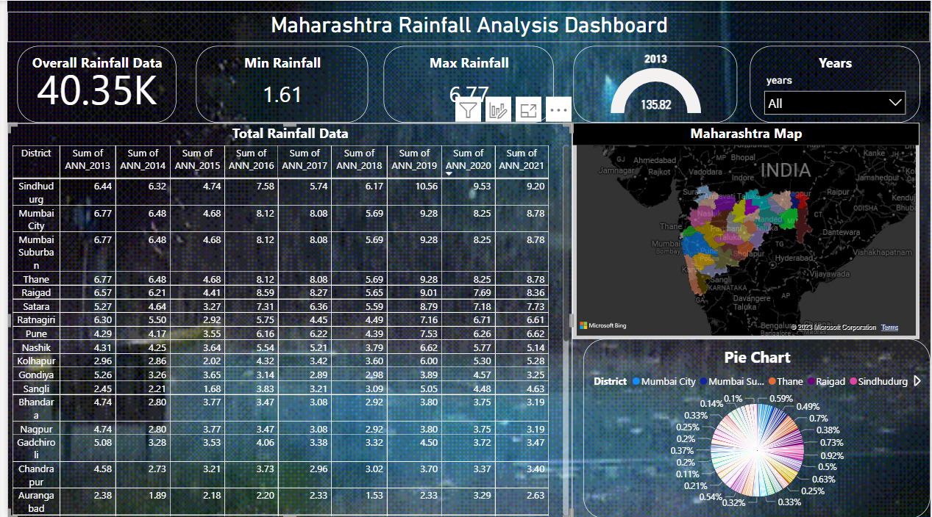

Fig1. Power-BI

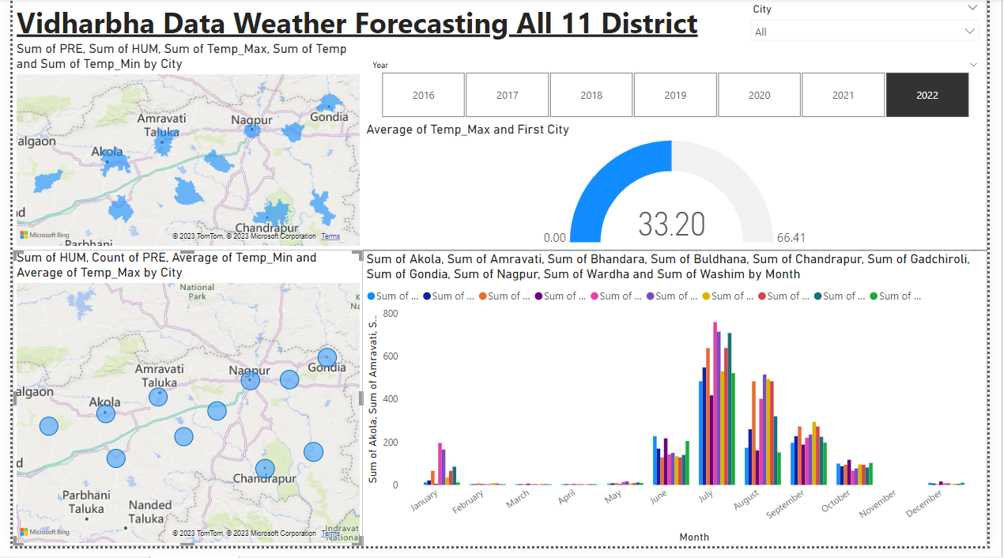

Fig2. Power-BI

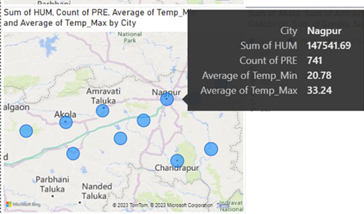

Fig. weather detail for Nagpur District

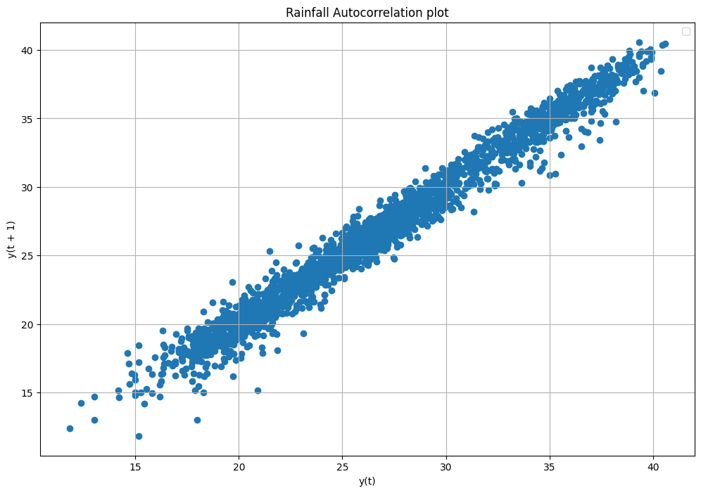

Fig. Nagpur Rainfall

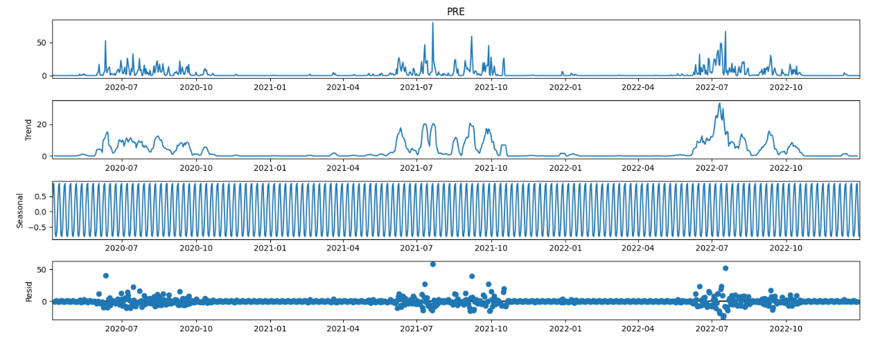

Fig. stats of Nagpur

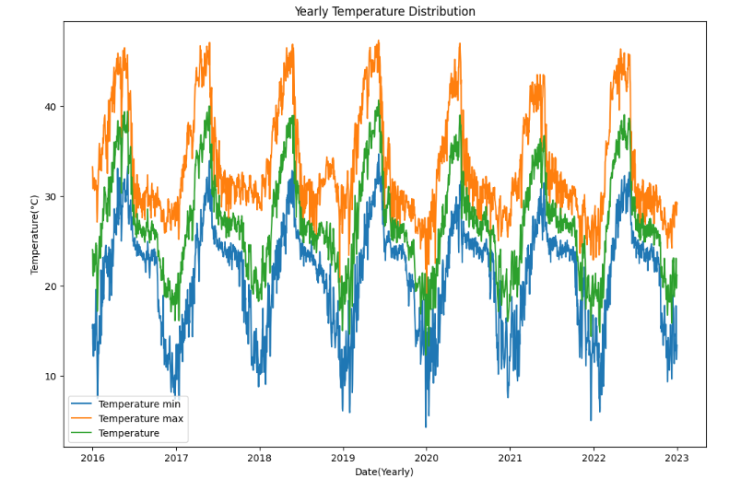

Fig. Yearly Temprature Disttibution

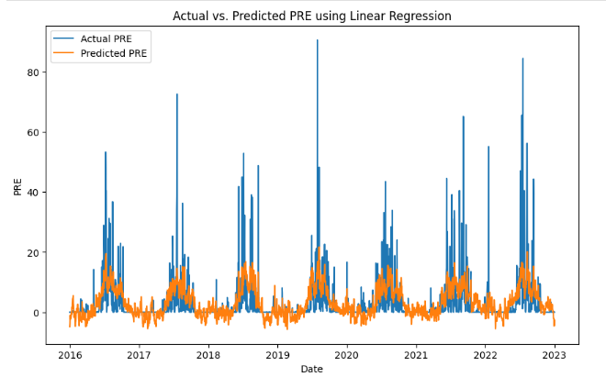

Fig. comparing Actual vs Predicted Precipitation

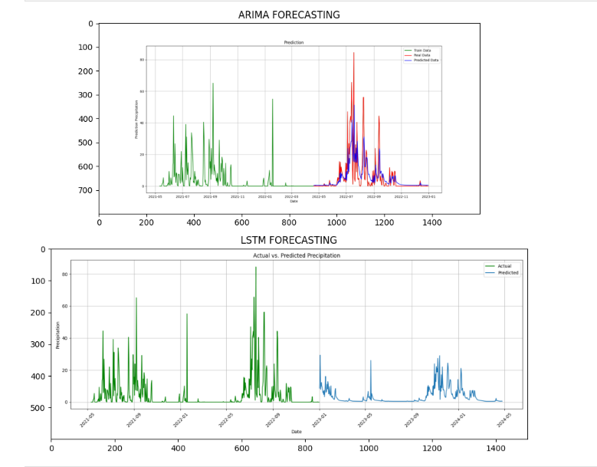

Fig. Arima & Lstm Forecasting

**2.7.1 Limitations of the System**

While developing the Rainfall prediction system for the Vidarbha dataset using deep learning, there are certain limitations that should be considered. These limitations may include:

* Data Limitations: The accuracy and reliability of the Rainfall predictions heavily depend on the quality and availability of the dataset. Limitations in the dataset, such as missing data, outliers, or biases, can impact the performance of the system.
* Model Generalization: Deep learning models trained on a specific dataset may have limitations in their ability to generalize to unseen data or different geographical regions. The system's performance may vary when applied to datasets from other regions with different climate patterns.
* Computational Requirements: Deep learning models often require significant computational resources, including powerful hardware and longer training times. These requirements may limit the scalability and accessibility of the system, especially for users with limited computational capabilities.
* Interpretability: Deep learning models are often considered black boxes, making it challenging to interpret the underlying reasons for Rainfall predictions. Lack of interpretability may limit the system's usefulness in certain applications where interpretability is crucial.
* External Factors: Rainfall prediction is influenced by various external factors such as atmospheric conditions, land cover changes, and other environmental factors. The system may not fully capture the impact of these external factors, leading to limitations in the accuracy of predictions.

**2.7.2 Conclusion**

In conclusion, the development of a Rainfall prediction system for the Vidarbha dataset using deep learning techniques has shown promising results. The system effectively processes Rainfall data, trains deep learning models, and provides accurate predictions. It offers valuable insights into Rainfall patterns and trends in the Vidarbha region.

The system's implementation and testing have demonstrated its potential in assisting various stakeholders, including weather forecasters, agricultural planners, and researchers, in making informed decisions based on Rainfall predictions.

**2.7.3 Future Scope of the Project:**

Although the developed Rainfall prediction system has achieved satisfactory results, there is still scope for further improvements and future enhancements. Some potential areas for future work include:

* Incorporating Additional Data Sources: Integrating additional data sources, such as satellite imagery, atmospheric data, or soil moisture data, can improve the accuracy and robustness of the Rainfall predictions.
* Ensemble Modeling: Exploring ensemble modeling techniques, where multiple models are combined, can potentially enhance the prediction accuracy and reliability.
* Fine-tuning Hyperparameters: Further optimization of deep learning model hyperparameters can improve the system's performance and make it more adaptable to different regions or climate conditions.
* Real-time Prediction: Extending the system to provide real-time Rainfall predictions, allowing users to access up-to-date and timely information.
* User Interface Enhancements: Improving the user interface and visualization capabilities to provide intuitive and interactive ways to explore Rainfall predictions and their variations.
* Integration with Decision Support Systems: Integrating the Rainfall prediction system with decision support systems for various applications such as agriculture, energy management, or urban planning, to provide valuable insights and support decision-making processes.

**CHAPTER 3: REFRENCES**

**3. REFERENCES**

1. Liang, Y., Han, Y., Huang, S., Wei, X., & Zhang, Z. (2019). "Short-Term Rainfall Prediction Based on Deep Learning with Meteorological Data." International Journal of Distributed Sensor Networks, 15(5), 1550147719851680.
2. Liu, Y., & Qian, G. (2019). "Deep Learning-Based Weather Forecasting Using Convolutional Neural Networks." Journal of Atmospheric and Oceanic Technology, 36(11), 2239-2250.
3. Rajabi, B., Ghahremanlou, V., & Golabchi, M. (2020). "A Novel Hybrid Deep Learning Model for Daily Rainfall Prediction." International Journal of Environmental Science and Technology, 17(10), 4749-4762.
4. Patel, N., Soni, R., & Kotecha, K. (2020). "Rainfall Prediction Using Deep Learning Techniques." In Proceedings of International Conference on Data Engineering and Communication Technology (pp. 387-397). Springer.
5. Zhang, W., Hu, Y., Li, B., & Hu, T. (2020). "Rainfall Prediction of Three Large Cities in China Based on Convolutional Neural Networks." Energies, 13(16), 4047.
6. Kulkarni, V. M., & Purandare, S. K. (2021). "Rainfall Prediction Using Convolutional Neural Network." In Proceedings of International Conference on Computational Intelligence and Data Engineering (pp. 409-417). Springer.
7. Zhang, W., Liu, B., Li, H., & Cao, L. (2021). "A Hybrid Deep Learning Framework for Rainfall Prediction." IEEE Access, 9, 24171-24183.
8. Huynh, T. L., Kim, S., Lee, S., & Jun, S. C. (2021). "Temporal Convolutional Networks for Accurate and Fast Rainfall Prediction." IEEE Transactions on Geoscience and Remote Sensing, 59(6), 4841-4855.
9. Huynh, T. L., Kim, S., & Jun, S. C. (2021). "Rainfall Prediction Using Attention-based Deep Learning Models." IEEE Access, 9, 41894-41905.
10. Chen, X., Huang, Z., Du, H., Liu, S., Xu, H., & Ma, T. (2021). "Rainfall Forecasting Based on Deep Learning for Hybrid Renewable Energy Power Generation Systems." Energies, 14(8), 2204.

**Appendices**

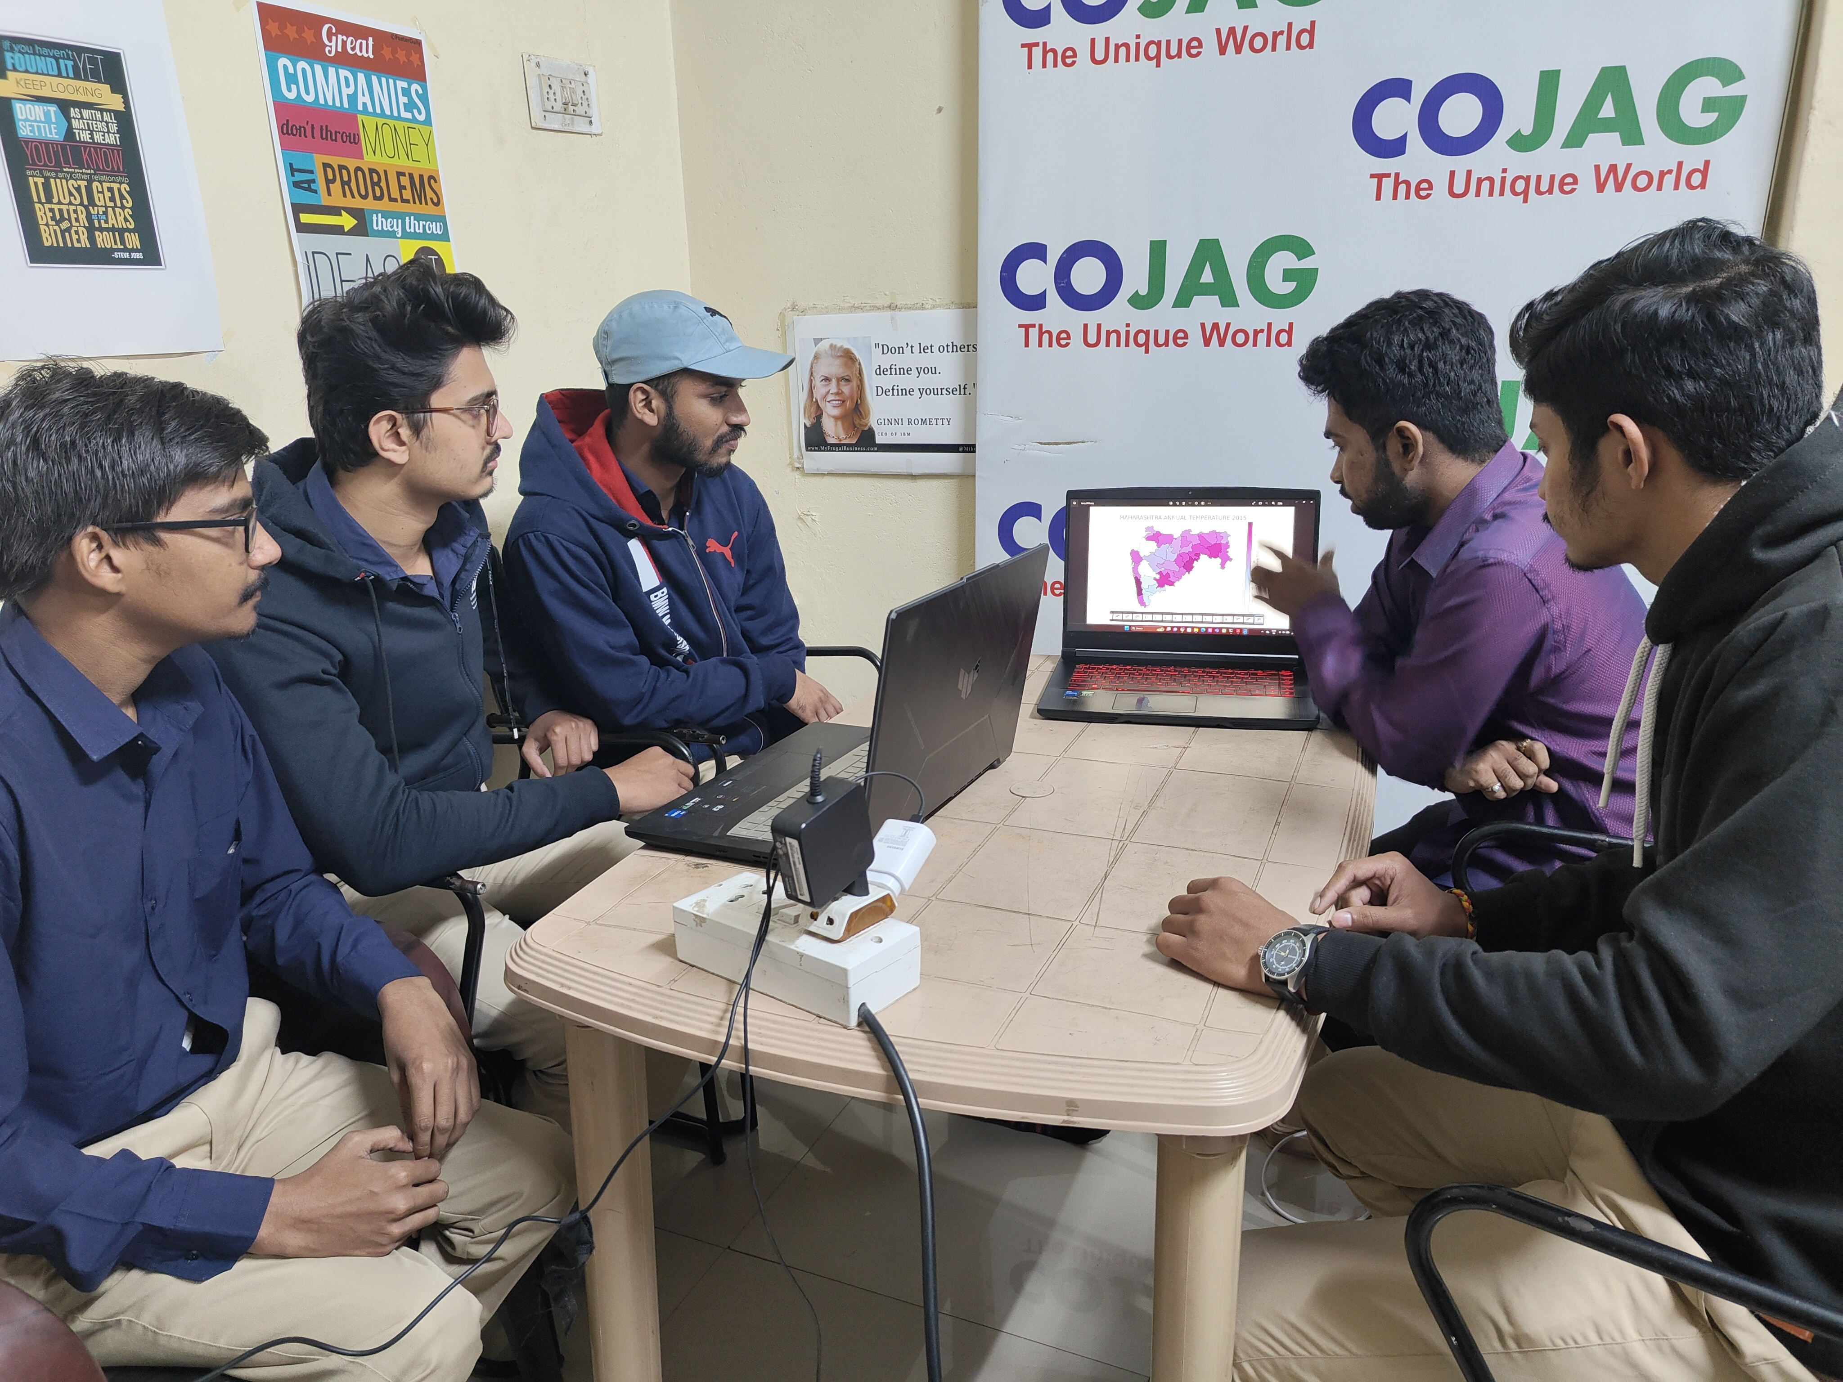

Session: 2023-2024

Class: VII_C IT

Title of Project: Vidarbha data weather forecasting using machine learning algorithm integrated with PowerBi Dashboard.

Name of Industry: Cojag Smart Technologies Pvt Ltd

Name of Supervisor: Mr. Sunny Meshram

Name of College Guide: Mr. Pravin Jaronde

Name of Student: Aniket Nehare